Preliminary Remedy Login Information

- You can find the client downloads at http://helpdesk.uh.edu
- The first link on http://helpdesk.uh.edu is Connect to Web-based Remedy. You can use the web-based version without installing the client if extracting reports is not on important.
- If you use the locally installed User Tool, please note:
  - Windows XP users should install UserTool7.1Patch11.exe
  - Windows 7 users should install ARSuiteKitClientWindows7.5Patch7.zip
    - The executable is located in Disk1->InstData->VM->Setup.exe
  - To login to the locally installed User Tool, please plugin the following credentials:
    - The user name will be the individual's CougarNet userid. The password will be in the following format: mmddyyx!
6-digit date of birth
x = first initial of your last name in lowercase
! = Exclamation Point
    - Preference Server should be elmo.e.uh.edu
    - TCP port is 1030
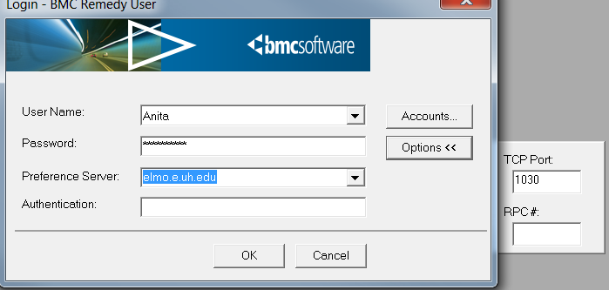

    - Once you have logged in successfully, please be sure to change your password. Upon changing your password, you will need to immediately login to the system again.
    - If you are off-campus or are using UHWireless or UHSecure on campus, then you will need to connect with VPN before launching the application.

If you should have any questions at all, please do not hesitate to contact me or my team at aad@uh.edu.

